**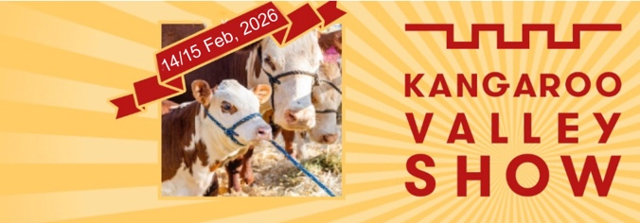  
  
EXHIBITOR APPLICATION FORM 2026  
  
Friday February 13 and Saturday February 14, 2026. :9am–11pm (optional end of trading times)  
$120 for 3x3m / $150 for 6x3 / big vans $200. Same fee for 1 or 2 days trading.   
Includes power / water / temporary food license, as applicable.   
Complete, sign and return this form to Lisa Anthony,** [**events@kangaroovalleyshow.org.au**](http://events@kangaroovalleyshow.org.au)

# *•* Set up from 7am. Bump in possible Weds 11, Thurs 12, 8am - 6pm, on agreement of Grounds team •  All vehicles offsite after 11am on show days. Parking areas close by.  Overnight security on site • Your site position non-negotiable on arrival

• You must include P/L insurance and food safety handling when returning this form  
• No single use plastics permitted  
• The below information is important as per Show and Council requirements - please complete it all.   
• You must also send your public liability insurance certificate. And Safe Food Handling as applicable.

|  |
| --- |
| Name: Trading As: |
| Street Address: |
| Mobile and Email: |
| Pitch size.  **W X D required**. |
| Power: **(number of outlets and amps)** |
| Are you applying for a community group or charity site? |

Once your application has been approved, you will be sent an invoice to pay within 14 days.  
No entry permitted unless you have paid and sent confirm to events@kangaroovalleyshow.org.au  
  
You must provide:   
1. Public Liability Insurance Certificate (minimum insured of $20,000,000).   
2. NSW Safe Food Handling Certificate / Food Permit (if applicable).  
  
**I and my employees, servants and agents shall observe and be bound by the Kangaroo Valley Show Society Terms, Conditions and regulations as outlined in this application.**

|  |
| --- |
| Name: _____________. Signature: _____________. Date: _____________. |

|  |
| --- |
| Insurance Declaration: I am a Hobbyist Stall Holder, do not have an ABN and do not earn more than $20,000 in this enterprise on an annual basis. I am therefore protected under the Show’s Liability policy for Public Liability only. I am aware that this protection does not extend to Products Liability. Name of applicant: _____________ Signature: _____________. Date: _____________. |

# 

# TERMS, CONDITIONS, REGULATIONS

# Public Liability Insurance

* Exhibitors, who are a commercial enterprise and have an ABN, must have current insurance policy, minimum $20M Public Liability cover and provide a copy of certificate of currency pre-event.
* Hobbyist Stallholders, (those who are not running a formal commercial enterprise, nor have an ABN and earn under $20,000 PA from their stall activity) are automatically covered under the Show’s insurance cover for Public Liability. The Show's Public Liability insurance does not extend to Hobbyists in any manner for any Products Liability exposure.

# NSW Safe Food Handling Certificate / Food Permit

# The operation of temporary/mobile food vending facilities at Kangaroo Valley Show falls within the jurisdiction of Shoalhaven City Council as an enforcement agency of the Food Authority of NSW.

# All temporary/mobile food vending facilities in operation at the Show be approved by Shoalhaven Council.

# Green Credentials

Kangaroo Valley is plastic free. All food must use either recyclable or compostable packaging and servery items (e.g., cutlery, containers, plates, cups, etc) and no plastic straws! No single use plastic bags.

# Electrical cables and power

* All electrical equipment on site is to be fitted with earth leakage circuit breakers. All equipment leads, tools and appliances must have been inspected and tagged by a licensed electrical contractor. This is essential for the safety requirement, public and is an obligation of Safe Work NSW. The Act imposes severe penalties in the event of non-compliance. Exhibitors who do not comply will not be allowed to trade.

**Indemnity**

* The Exhibitor shall indemnify and hold harmless the Kangaroo Valley Show Committee against all loss or damage, directly or indirectly arising from any breach of these conditions or any law by the Exhibitor or any negligent act or omission by the Exhibitor.

**Cashless Systems**

The KV Show is as cashless as possible. Please enquire if further advice is required.

**Security**

* The Kangaroo Valley Show Society Inc. provides a limited number of security personnel who are in attendance. Specific security for individual Site holders should be arranged privately at their own expense. The Kangaroo Valley Show Society Inc. will not themselves be responsible for the safety of any articles of any kind brought onto the Showground by exhibitors, their servants, agents or contractors or any person whatsoever.

**Vehicles during Show**

# Vehicle movement during the show is prohibited unless the vehicle is supervised by a delegated show representative, wearing a high vis jacket, walking pace only for the vehicle whilst displaying hazard lights.

# Community displays

* Space is available for community groups and registered charities at reduced rates.

# Other: - Product exclusivity: Only products listed may be sold at the show to ensure the exclusivity of your product. Failure to declare any product sold may result in the withdrawal of your 2026 show vending authority. - Deliveries: The Kangaroo Valley Show will not accept delivery on behalf of the exhibitor. Promotional items: Any promotional material to be handed out may only be done so within a vendor’s prescribed site.